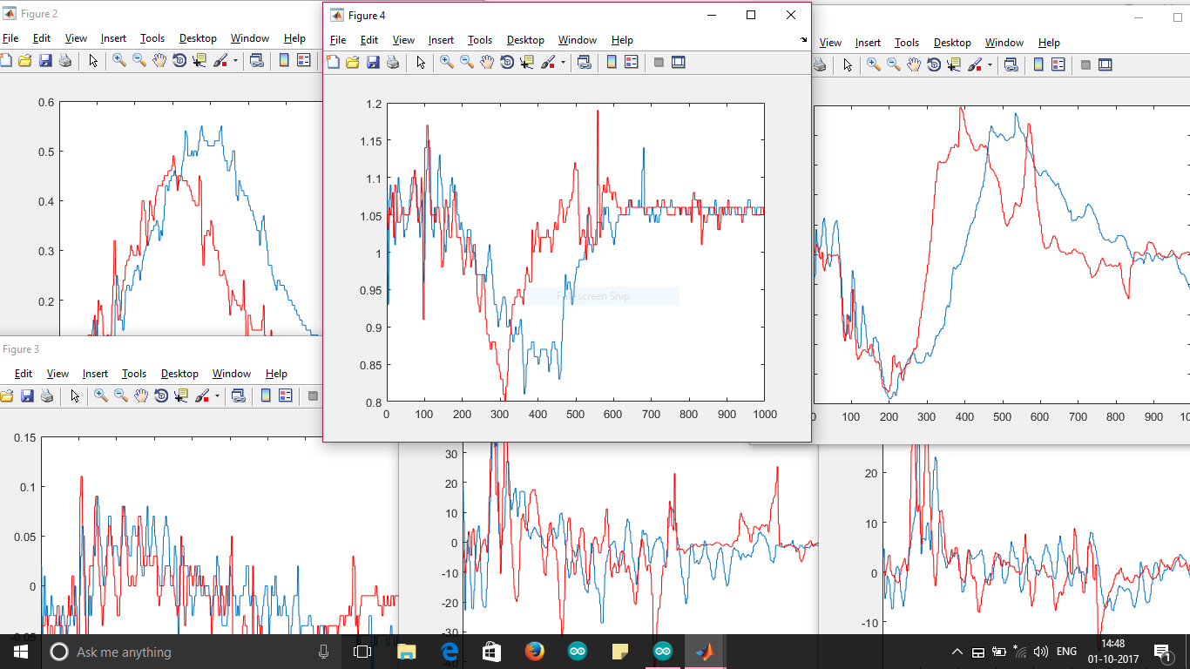

>> gesture_sensors3

Waiting for User input to record Primary Gesture

User input Received

Recording Primary Gesture

Primary Gesture Recorded

Waiting for User input to record Secondary Gesture

User input Received

Recording Secondary Gesture

Secondary Gesture Recorded

p

0.0000 0.0000 0.0000 0.6644 0.0000 0.0000

r

0.7717 0.5492 0.5386 0.3304 0.6474 0.4232

Gesture Recognised

>>

Ax



Az



Ay



Gx



Gy



Gz



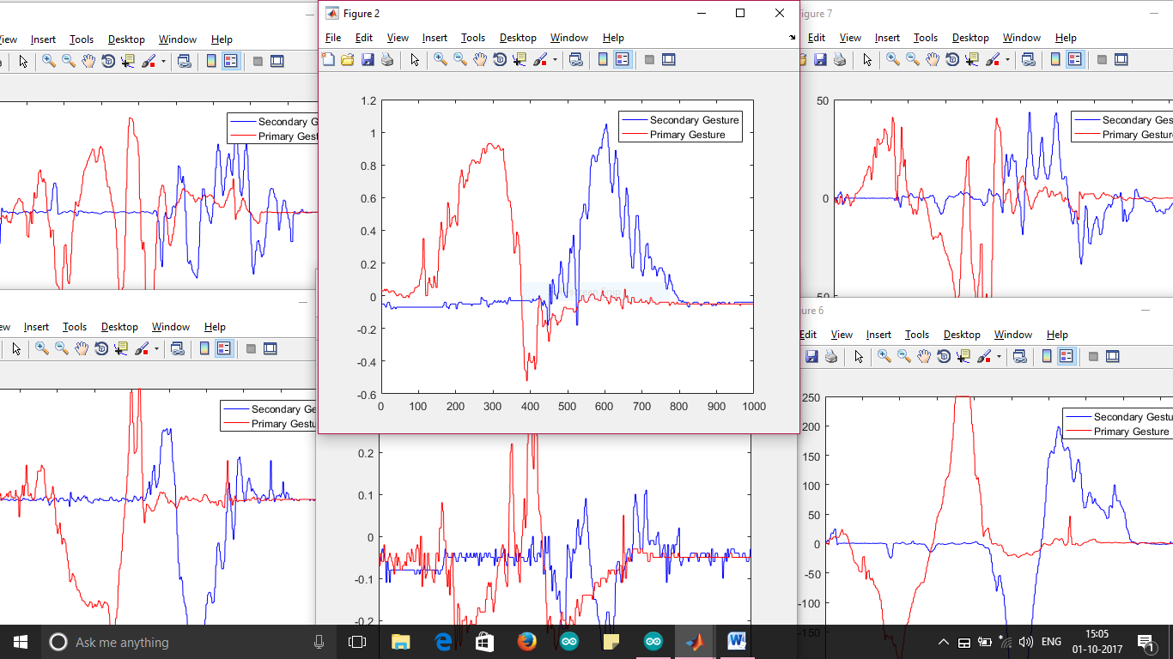

>> gesture_sensors3

Waiting for User input to record Primary Gesture

User input Received

Recording Primary Gesture

Primary Gesture Recorded

Waiting for User input to record Secondary Gesture

User input Received

Recording Secondary Gesture

Secondary Gesture Recorded

p

0.0000 0.0000 0.0441 0.8642 0.0241 0.8238

r

-0.2115 0.1443 -0.0637 0.0054 0.0713 0.0071

Gesture Not Recognised

>>

Ax



Ay



Az



Gx



Gy



Gz

